Title of the Project
SEMINAR HALL BOOKING SYSTEM

INTRODUCTION
To design and develop an online Seminar Hall booking application which will allow internal users and external users also to book Seminar Hall as per their expected event schedules. Any user internal or external has to raise a request for Seminar Hall booking and it will be approved by admin. A logged in user can check availability date wise and hourly wise too. Will have the option to provide the hourly availability info too while raising the request. The home page of the system shows the available seminar halls details on particular dates, after user’s book the venue then all the details can be visible on the screen that the seminar hall name, number, date, time, etc.
The main aim of developing this seminar hall or function hall booking system project is to provide online seminar hall booking platform to the students in their colleges or schools or universities.
The project is totally controlled at administrative end and department member can only request to administrator shall guaranty the access. The purpose of the project is to build an application program to reduce the manual work for managing the booking seminar hall via web application. It tracks all the details about the status of booking, approval or rejected or amended. It manages all the information about seminar hall. Report generation: It generates the report on seminar hall status and history.
OBJECTIVES
The main objective of the Seminar Hall Booking System is to manage the details of seminar hall booking dates, history, and availability managed by all departments. The system keeps records of seminar hall booking along with associated event details and user contact in a well-maintained database. It should maintain a well-organized database for storing the resources that are provided by the admin and the faculty. Eliminates the entering of invalid data. The system should cover almost all the functional areas.

PROJECT CATEGORY
RDBMS
RDBMS is the acronym for relational Database Management System. The most prominent RDBMS packages are Oracle, Sybase, Informix and SQL Server. A collection of interrelated data is referred to as a database. A database management coordinated the storage and retrieval of data and ensures integrity, consistency and availability. A database system consists of mainly two parts: Database Management system, which is the program that organizes and maintains the information and database application. And a program that lets retrieval,viewing and updating the information stored by DBMS.

An DBMS offers the following services:
- Data Definition: This is the method of defining and storing set of data.
- Data Maintenance: This is the method of storing and maintaining the data.
- Data Manipulation: this is the method of adding, updating the data.
- Data Integrity: It ensures the accuracy of data.
- Communication: It communicates with the network.
- Utilities: It exports and imports the data.

OOPS
The major objective of the approach is to eliminate some of the flaws encountered in the procedural approach. OOP treat data as a critical element in program development and does not allow it to flow freely around system. OOPs allow us to decompose a problem into a number of entities called objects and then build data and function around these entities.

FEATURES
- ABSTRACTION
- ENCAPSULATION
- MODULARITY
- INHERITANCE
- POLYMORPHISM

TOOLS/PLATFORM
HARDWARE REQUIREMENTS
The selection of hardware is very important in the existence and proper working of any software. When selecting hardware, the size and capacity requirements are also important. Below is some of the hardware that is required by the system
Processor : Intel i3 or more
RAM : 4GB of RAM
Hard Disk Space : 500GB free hard disk space
Input Devices : Mouse, Keyboard
Output Devices : Monitor, Printer
SOFTWARE SELECTION
We require much different software to make the application which is in making to work efficiently. It is very important to select the appropriate software so that the software works properly.
Below is the software that are required to make the new system.
1. Windows 8 or higher versions
2. Python -Django
3. MySQL
Python - Django Framework
Python is a high-level, object-oriented programming language that is widely used for web development, scientific computing, data analysis, and artificial intelligence applications. One of the most popular web frameworks for Python is Django, which is an open-source, Model-View-Controller (MVC) architecture web framework that allows for the rapid development of web applications.
Django has several characteristics that make it a popular choice for web development, including:
- DRY (Don't Repeat Yourself) principle: Django follows the DRY principle, which means that developers only need to write code once for a particular task, rather than repeating it in multiple places. This reduces the amount of code needed to develop a web application and makes it easier to maintain.
- Batteries included: Django includes many built-in features and libraries that make it easier to develop complex web applications. This includes features like authentication, admin interface, and automatic database schema generation.
- ORM (Object Relational Mapping): Django uses an ORM to interact with the database, which means that developers can work with database objects as if they were Python objects. This makes it easier to write code that interacts with the database and reduces the likelihood of SQL injection attacks.
- MVC architecture: Django follows the Model-View-Controller (MVC) architecture, which separates the application logic into three separate components: the model (data), the view (presentation), and the controller (logic). This separation of concerns makes it easier to maintain and test web applications.
- URL routing: Django includes a powerful URL routing system that allows developers to map URLs to specific views in the application. This makes it easy to create complex URLs and to handle URL-based logic.
VISUAL STUDIO CODE
Visual Studio is a powerful developer tool that you can use to complete the entire development cycle in one place. It is a comprehensive integrated development environment (IDE) that you can use to write, edit, debug, and build code, and then deploy your app. Beyond code editing and debugging, Visual Studio includes compilers, code completion tools, source control, extensions, and many more features to enhance every stage of the software development process
MY SQL
MySQL exceeds dependability requirements and provides innovative capabilities that increase employee effectiveness, integrate heterogeneous IT ecosystems, and maximize capital and operating budgets. MySQL provides the enterprise data management platform the organization needs to adapt quickly in a fast-changing environment. With the lowest implementation and maintenance costs in the industry, MySQL delivers rapid return on data management investment. It supports the rapid development of enterprise-class business applications that can give an insurance company a critical competitive advantage. Benchmarked for scalability, speed, and performance, it is a fully enterprise-class database product, providing core support for Extensible Markup Language (XML) and Internet queries.

PROBLEM ANALYSIS
The first steps in the initial investigation are directed towards clarifying the problems of the existing system. The existing system uses manual method for the whole process such as manually booking the seminar hall, checking availability and knowing the status etc. This requires a lot of hard work and time consumption to complete the task. This may include human errors. In the existing system, it is difficult to retrieve some particular information. In spite of all the efforts undertaken, the destruction of data may happen often. Hence, the computerization of the system in finding out or predicting the disease to an extent helps a lot.

REQIIREMENT SPECIFICATIONS
A required specification is a structured document, which sets out the system services in detail. This document, also called a functional specification, which should be precise. It may serve as a contract between the system buyer and the software developer. The requirement specifications define the basic specifications of the user for the new system.
The software required for developing the “Seminar Hall Booking System” are Windows 8 as Os, Python as front end for designing GUI, MySQL for data storage.
The administrator should get the supreme authority over the database and all the processes Each user should have unique identification. Username and password are given by the administrator.
The SRS document itself states in precise and explicit language those functions and capabilities a software system must provide, as well as states any required constraints by which the system must abide. The SRS also functions as a blueprint for completing a project with as little cost growth as possible. The SRS is often referred to as “parent” document because all subsequent project management documents, such as design specifications, statement of works, software architecture specifications, testing and validation plans, and documentation plans , are related to it.
It’s important to note that an SRS contains functional and non-functional requirements only; it doesn’t offer design suggestion, possible solutions to technology or business issues, or any other information other than what the development team understands the customer system requirement to be.
Functional requirements of the “Seminar Hall Booking System” are:
- The system should provide required outputs under any conditions. bookings should be accurate.
- Only administrator should be allowed to access database.
- The admin and user can login only through user name and passwords.
Non-Functional requirements of the system are reliability, portability and performance. “Seminar Hall Booking System” mainly focuses on the reliability, security and time. This system will provide with the reliability that the user expects. It reduces the time consumed when compared to manual system. The data will be stored securely.

GANTT CHART
 | DEC | JAN-APRIL | MAY | JUNE
Analysis
Design
Development
Testing
Bug Fixing

DATA FLOW DIAGRAM
Level 0 Context Level
Level 1 Admin

Level 1 Department

Level 1 User

ENTITY RELATIONSHIP DIAGRAM
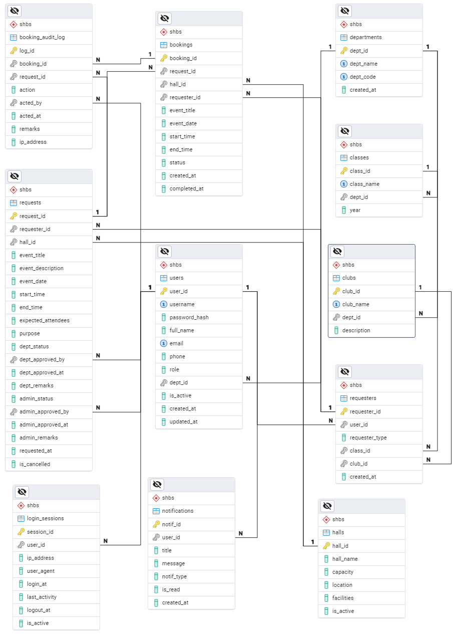

Table design
departments

Field Name | Data Type | Constraint | Description
dept_id | SERIAL | PRIMARY KEY | Auto-generated Department ID
dept_name | VARCHAR 100 | NOT NULL | Name of the department
dept_code | VARCHAR 10 | UNIQUE | Short code (e.g. CSE ECE)
created_at | TIMESTAMPTZ | DEFAULT NOW() | Record creation time
classes

class_id | SERIAL | PRIMARY KEY | Auto-generated Class ID
class_name | VARCHAR 100 | NOT NULL | Example: BCA 2023-26 CSE S3
dept_id | INTEGER | FOREIGN KEY → departments.dept_id | Department to which class belongs
year | VARCHAR 10 |  | Batch year
clubs

club_id | SERIAL | PRIMARY KEY | Auto-generated Club ID
club_name | VARCHAR 150 | NOT NULL UNIQUE | Example: Robotics Club NSS
dept_id | INTEGER | FOREIGN KEY → departments.dept_id (NULLABLE) | NULL = College-level club
description | TEXT |  | Club details
halls

hall_id | SERIAL | PRIMARY KEY | Auto-generated Hall ID
hall_name | VARCHAR 100 | NOT NULL | Hall name
capacity | INTEGER | NOT NULL CHECK > 0 | Maximum seating
location | VARCHAR 100 |  | Building/Floor
facilities | JSONB | DEFAULT '{}' | Example: {"projector":true,ac:true}
is_active | BOOLEAN | DEFAULT true | Active status
users

user_id | SERIAL | PRIMARY KEY | Auto-generated User ID
username | VARCHAR 50 | NOT NULL UNIQUE | Login username
password_hash | VARCHAR 255 | NOT NULL | Hashed password
full_name | VARCHAR 100 | NOT NULL | Full name of user
email | VARCHAR 100 | UNIQUE | Email address
phone | VARCHAR 15 |  | Contact number
role | USER_ROLE | NOT NULL | ENUM: admin/dept_coordinator/requester/faculty
dept_id | INTEGER | FOREIGN KEY → departments.dept_id | For coordinators & faculty
is_active | BOOLEAN | DEFAULT true
created_at | TIMESTAMPTZ | DEFAULT NOW()
requesters

requester_id | SERIAL | PRIMARY KEY
user_id | INTEGER | NOT NULL UNIQUE → users.user_id | One user = one requester
requester_type | REQUESTER_TYPE | NOT NULL | ENUM: class or club
class_id | INTEGER | FOREIGN KEY → classes.class_id (NULL if club)
club_id | INTEGER | FOREIGN KEY → clubs.club_id (NULL if class)
created_at | TIMESTAMPTZ | DEFAULT NOW()
requests

request_id | SERIAL | PRIMARY KEY
requester_id | INTEGER | NOT NULL → requesters.requester_id
hall_id | INTEGER | NOT NULL FOREIGN KEY → halls.hall_id
event_title | VARCHAR 200 | NOT NULL | Event name
event_description | TEXT |  | Event details
event_date | DATE | NOT NULL | Date of event
start_time | TIME | NOT NULL
end_time | TIME | NOT NULL | CHECK end_time > start_time
expected_attendees | INTEGER | CHECK > 0
purpose | VARCHAR 300
dept_status | APPROVAL_STATUS | DEFAULT 'pending'
dept_approved_by | INTEGER | → users.user_id
dept_approved_at | TIMESTAMPTZ
dept_remarks | TEXT
admin_status | APPROVAL_STATUS | DEFAULT 'pending'
admin_approved_by | INTEGER | → users.user_id
admin_approved_at | TIMESTAMPTZ
admin_remarks | TEXT
requested_at | TIMESTAMPTZ | DEFAULT NOW()
is_cancelled | BOOLEAN | DEFAULT false
bookings

booking_id | SERIAL | PRIMARY KEY
request_id | INTEGER | NOT NULL UNIQUE → requests.request_id
hall_id | INTEGER | NOT NULL → halls.hall_id
requester_id | INTEGER | NOT NULL → requesters.requester_id
event_title | VARCHAR 200 | NOT NULL
event_date | DATE | NOT NULL
start_time | TIME | NOT NULL
end_time | TIME | NOT NULL
status | BOOKING_STATUS | DEFAULT 'confirmed'
created_at | TIMESTAMPTZ | DEFAULT NOW()
completed_at | TIMESTAMPTZ | When event actually ended
Booking_audit_log

log_id | SERIAL | PRIMARY KEY
booking_id | INTEGER | → bookings.booking_id
request_id | INTEGER | → requests.request_id
action | VARCHAR 50 | NOT NULL | Example: Approved Rejected Cancelled
acted_by | INTEGER | NOT NULL → users.user_id
acted_at | TIMESTAMPTZ | DEFAULT NOW()
remarks | TEXT
Login_sessions

session_id | VARCHAR 255 | PRIMARY KEY
user_id | INTEGER | NOT NULL → users.user_id
ip_address | INET
user_agent | TEXT
login_at | TIMESTAMPTZ | DEFAULT NOW()
last_activity | TIMESTAMPTZ | DEFAULT NOW()
logout_at | TIMESTAMPTZ | NULL = active session
notifications

notif_id | SERIAL | PRIMARY KEY
user_id | INTEGER | NOT NULL → users.user_id
title | VARCHAR 150
message | TEXT | NOT NULL
notif_type | VARCHAR 30 |  | DEFAULT 'info'
is_read | BOOLEAN | DEFAULT false
created_at | TIMESTAMPTZ | DEFAULT NOW()

MODULE DESCRIPTION
Modules:
- Admin- can manage the details of departments, update status of bookings etc. Admin has the main role over the system. Features of Admin are as follows:
  - Manage department details.
  - view faculties
  - Manage seminar halls.
  - Manage hall availability.
  - Accept or reject booking.
  - Report Generation
- Department: can receive the requests from their class or club for seminar hall and manage other details.Major features of department are as follows
- Manage faculties
- Manage department class or batches
- Manage departments club details.
- View request from users.
- Forward the request to admin.
- Report generation
- User: A user can either be a club or a class
  - Request for seminar hall
  - Booking Status

IMPLEMENTATION AND TESTING STRATEGIES
Implementation is the stage of the project when the theoretical stage is turned out into a working system. Thus it can be considered as the most crucial stage to achieve a successful system. This phase involves the construction of actual project result. The process of implementation depends on the characteristics of project. The implementation stage involves careful planning, investigation of existing system, constraints of implementation etc. This work is implemented to avoid undesired message from undesired creators by using filtering rules and black list rules.
Implementation methods
Implementation is the stage of the project when the theoretical stage is turned out into a working system. Thus it can be considered as the most crucial stage to achieve a successful system. This phase involves the construction of actual project result. The process of implementation depends on the characteristics of project. The implementation stage involves careful planning, investigation of existing system, constraints of implementation etc. This work is implemented to avoid undesired message from undesired creators by using filtering rules and black list rules
Implementation Plan:
Implementation plans are intended to be scalable and flexible; reflecting the degree of urgency, innovation, complexity and/or sensitivity.
TESTING
Testing is a process of executing a program with the interest of finding error. A good test is one that has high probability of finding the yet undiscovered error. Testing should systematically uncover different classes of error in a minimum amount t of time with a minimum number of efforts. Two classes of inputs are provided to test the process.
- A software configuration that configuration that includes a software requirements specification, a design specification and source code.
- A software configuration that includes a test plan and procedure, any testing tool and test cases and their expected result.

Testing is divided into several distinct operations.
1. Unit Testing
This testing is carried out during the programming stage itself. In this testing step each module is found to be working satisfactorily as regards to the expected output from the module. Using a method called white box testing in which the software tester has knowledge of the inner workings, structure and language of the software, or at least its purpose and where each module or component of the software is tested individually. In the unit test case we will be testing the separate modules of the Software. We will test the components by passing data through it and we will be monitoring data to find the errors. We will be looking for entry and exit conditions of the data. We will make sure that all the components work without any troubles.
2. Integration Testing
After splitting the program into units, the units were tested together to see the defects between each module and function. It is testing two or more modules or functions together with the intent of finding interface defects between the modules or functions. Testing completed at as part of unit or functional testing, and sometimes, becomes its own standalone test phase. On a larger level, integration testing can involve putting together of groups of modules and functions with the goal of completing and verifying that the system meets the system requirements.
- Validation Testing
After validation testing , software is completely assembled as a package, interfacing errors that have been uncovered and corrected and the final series of software test; the validation test begin.
Steps taken during software design and testing can greatly improve the probability of successful integration in the larger system. System testing is actually a series of different test whose primary purpose is to fully exercise the compute-based system.
- Recovery Testing
It is a system that forces the software to fail in a variety of ways and verifies that the recovery is properly performed.
- Security Testing
It attempts to verify that protection mechanism built into a system will in fact protect it from improper penetration. The system’s security must of course be tested from in vulnerability form frontal attack
- Stress Testing
Stress tools are designed to confront programs with abnormal situations. Stress testing executes a system in a manner that demands resources in abnormal quantity and volume.
- Black Box Testing
Black box testing is done to find out the following information as shown in below:
- Incorrect or missing functions.
- Interface errors.
- Errors or database access.
- Performance error.
- Termination error.
The mentioned testing is carried out successfully for this application according to the user’s requirement specification.
- Test Data Output
After preparing test data, the system under study is tested using the test data. While testing the system using test data, errors are again uncovered and corrected by using above testing and corrections are also noted for future use.

FUTURE SCOPE AND FURTHER ENHANCEMENT
Any system which has been in use for a number of years gradually decays and become less effective because of change in environment to which it has to be adapted. For the time being it is possible to overcome problems by amendments and minor modifications to acknowledge the need of fundamental changes.

“Seminar Hall Booking System” satisfies the requirements of the management. The system is developed in a user friendly manner. It has one module for manipulating the database. The application can be enhanced in the future with the needs of the management. The database and the information can be updated to the latest coming versions. There are also possibilities for enhancing and further developing the project with the latest information and needs of the management, since the coding are in procedural block formats, altering the code is also made easy.

BIBLIOGRAPHY
Elias. M. Awad, “System Analysis and Design”, Galgoeia publications – Second Edition2005.
Henry Korth,” Data Base Design Concept”, Mc grew hill – Fifth Edition 2001. Roger.S.Pressman,” Software Engineering “,Mc grew hill Fifth Edition 2006.
www.stackoverflow.com
www.javatpoint.com

